UI bug 2 –

1. Bug Title: Unable to read text on buttons when text colour is changed to Red.
2. Steps to Reproduce:
3. Select the Accessibility adjustments icon on the home page.
4. Set Font color to Red.
5. Try to find the button “Explore the ebook” .
6. Actual Result: Button text is not visible because button colour remains Dark green. Red text does not show clearly on this button colour.
7. Expected Result: Button colour should also be changed to a lighter colour so that dark-coloured text is visible clearly.
8. Screenshots or screencast URL: <URL of screenshots/screencast of the issue>



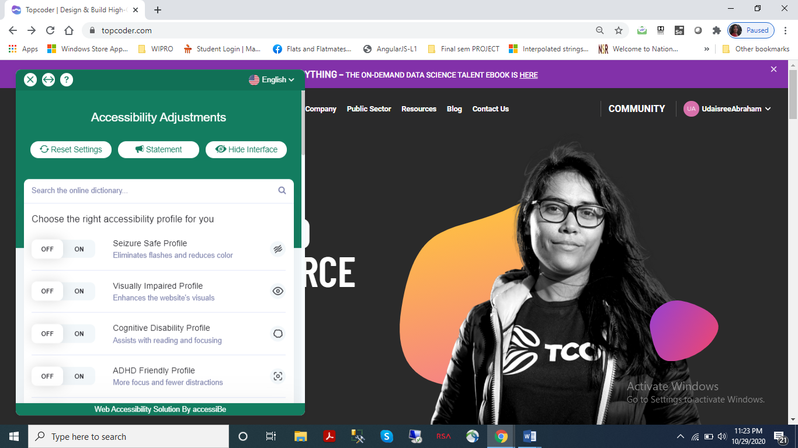

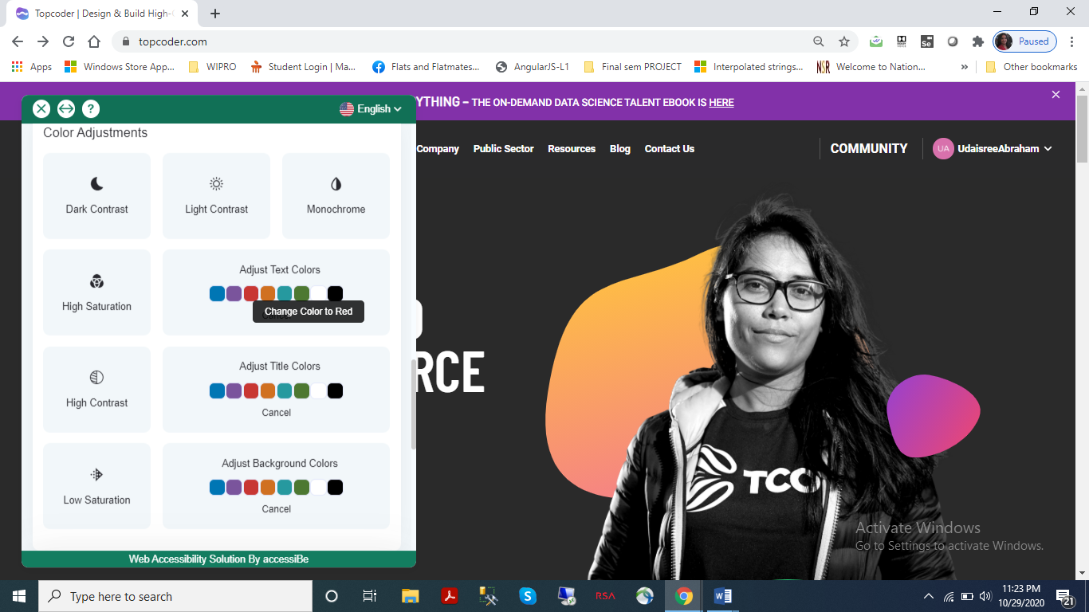

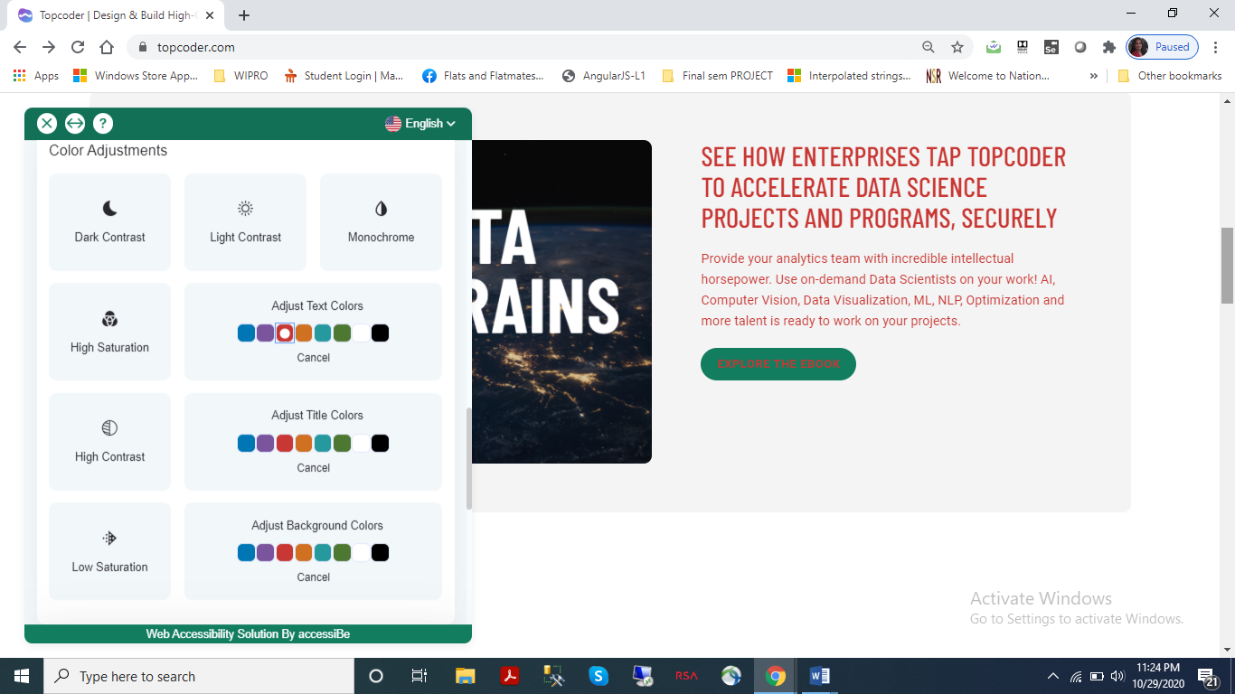

1. Device/OS/Browser Information: <Detailed device, OS and Browser information>

1. Device – HP Probook laptop

2. OS – Windows 10

3. Browser – Google chrome